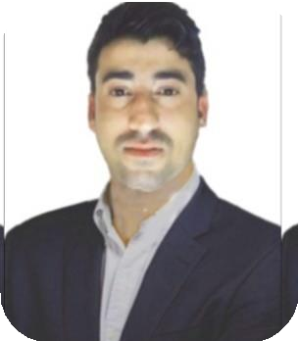

•

•

•

•

•

**English : Speak 70%, Listen 80% & Write 90%**

**Hindi**

**: Speak 70%, Listen 80% & Write 90%**

**Bengali : Speak 40%**

**Gujarati : Speak 30%**

**Arabic : Speak 30%**

# Yash Pal

**STORE KEEPER**

**Contact**

# Career Objectives

Seeking a challenging carrier in the evergrowing field of merchandiser. Best utilizing my experience, technical ability, analytical & problem solving skills. The job role manages timely receiving of materials/items at stock/stores yard in a construction site and inventory through computer system.

# Work Experience

* **Assistant Systems Operator**

Reliance Refinery Gujarat,India ( 2018 To 2019)

# Software Technical Coordinator

Oman National Engineering Investment Company, Oman (Since 08-2020 To Till Date)

**Technical Skills Language**: Java, JavaScript & Python **Database**: MySQL, Oracle & DB2 **Frameworks:** JSF, J2EE & Apache

 **Current Location : Sultan Qaboos University Hospital , P.O- Box 38, P.C – 123. Al**

**Khod. Sultanate Of Oman**

**🕾 +968-94230481,**

**+91-8626935756**

 [**paly7841@gmail.com**](mailto:paly7841@gmail.com)

**API’s** : JNDI, Servlets & EJB

# Area Of Expertise

* Project Management
* Strategic Planning
* Team Leadership & Development
* Scrum & Agile Methodologies

**Education**

* **Information Technology** Pursue : Lovely Professional University, Jalandhar-Delhi

G.T. Road (NH-1), Phagwara, Punjab (INDIA) From: 2019-2023 July)

* **Diploma in industrial safety**: management from ministry of Shipping, Patna Gai Ghat (NINI)

# Languages

**Personal Details Hobbies**

Name : Yashpal Father’s Name : Inder Singh Nationality : Indian

Date Of Birth : 17-Oct-1992 Religion : Hindu

Gender : Male

Marital Status : Single

Passport No. : R5518235 Passport Issue Date : 22-Nov-2017 Passport Exp. Date : 21-Nov-2027

 **Reading** **Writing**

 **Travel 🖭 Music**

I Hereby declare that all the given particular and details are true to the best of my knowledge and belief a I am also willing to give my best for the company.